数据库实验教学中使用到的数据库
雇员与部门数据库
- 数据库结构与记录

Dept(部门)表结构
属性列表 | 含义 | 数据类型
DEPTNO | 部门编号 | NUMBER(2)
DNAME | 名称 | VARCHAR2(14)
LOC | 地址 | VARCHAR2(13)
主码:DEPTNO

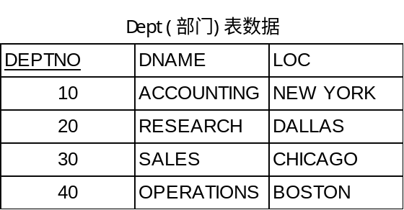

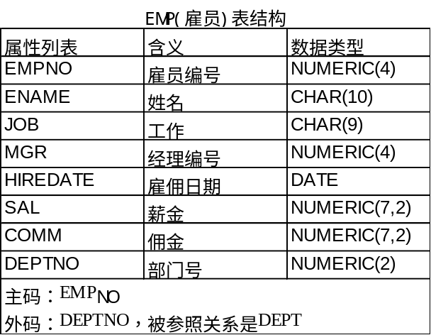
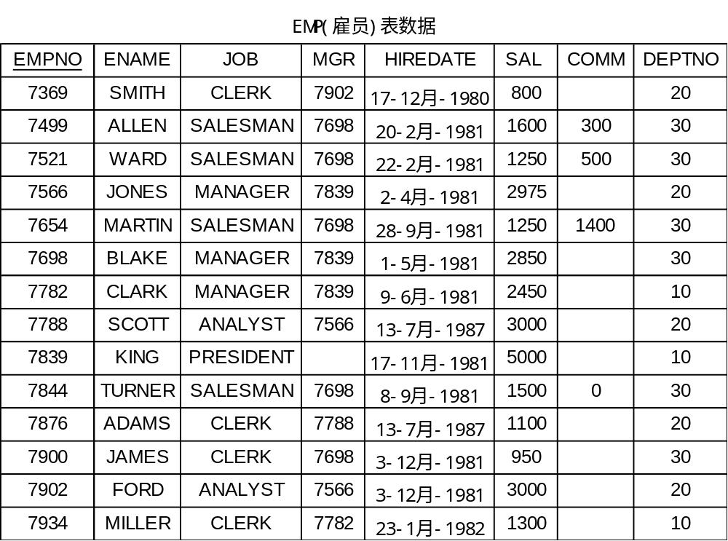

2．数据库表的创建与数据输入
CREATE TABLE DEPT
(DEPTNO NUMBER(2) CONSTRAINT PK_DEPT PRIMARY KEY,
DNAME VARCHAR2(14) ,
LOC VARCHAR2(13) ) ;

CREATE TABLE EMP
(EMPNO NUMBER(4) CONSTRAINT PK_EMP PRIMARY KEY,
ENAME VARCHAR2(10),
JOB VARCHAR2(9),
MGR NUMBER(4),
HIREDATE DATE,
SAL NUMBER(7,2),
COMM NUMBER(7,2),
DEPTNO NUMBER(2) CONSTRAINT FK_DEPTNO FOREIGN KEY REFERENCES DEPT);

INSERT INTO DEPT VALUES (10,'ACCOUNTING','NEW YORK');
INSERT INTO DEPT VALUES (20,'RESEARCH','DALLAS');
INSERT INTO DEPT VALUES (30,'SALES','CHICAGO');
INSERT INTO DEPT VALUES (40,'OPERATIONS','BOSTON');

INSERT INTO EMP VALUES (7369,'SMITH','CLERK',7902,to_date('17-12-1980','dd-mm-yyyy'),800,NULL,20);
INSERT INTO EMP VALUES (7499,'ALLEN','SALESMAN',7698,to_date('20-2-1981','dd-mm-yyyy'),1600,300,30);
INSERT INTO EMP VALUES (7521,'WARD','SALESMAN',7698,to_date('22-2-1981','dd-mm-yyyy'),1250,500,30);
INSERT INTO EMP VALUES (7566,'JONES','MANAGER',7839,to_date('2-4-1981','dd-mm-yyyy'),2975,NULL,20);
INSERT INTO EMP VALUES (7654,'MARTIN','SALESMAN',7698,to_date('28-9-1981','dd-mm-yyyy'),1250,1400,30);
INSERT INTO EMP VALUES (7698,'BLAKE','MANAGER',7839,to_date('1-5-1981','dd-mm-yyyy'),2850,NULL,30);
INSERT INTO EMP VALUES (7782,'CLARK','MANAGER',7839,to_date('9-6-1981','dd-mm-yyyy'),2450,NULL,10);
INSERT INTO EMP VALUES (7788,'SCOTT','ANALYST',7566,to_date('13-7-1987','dd-mm-yy'),3000,NULL,20);
INSERT INTO EMP VALUES (7839,'KING','PRESIDENT',NULL,to_date('17-11-1981','dd-mm-yyyy'),5000,NULL,10);
INSERT INTO EMP VALUES (7844,'TURNER','SALESMAN',7698,to_date('8-9-1981','dd-mm-yyyy'),1500,0,30);
INSERT INTO EMP VALUES (7876,'ADAMS','CLERK',7788,to_date('13-7-1987', 'dd-mm-yy'),1100,NULL,20);
INSERT INTO EMP VALUES (7900,'JAMES','CLERK',7698,to_date('3-12-1981','dd-mm-yyyy'),950,NULL,30);
INSERT INTO EMP VALUES (7902,'FORD','ANALYST',7566,to_date('3-12-1981','dd-mm-yyyy'),3000,NULL,20);
INSERT INTO EMP VALUES (7934,'MILLER','CLERK',7782,to_date('23-1-1982','dd-mm-yyyy'),1300,NULL,10);

